**Level-of-Detail Advanced**

Advanced Demonstrations of Level-of-Detail (LOD) where the levels contain multiple 3d objects. This requiring several of those 3d objects to be inside a <Transform> or <Group> node, instead of just a single 3d object per level inside a <Shape> node without <Transform> or <Group>.

**Levelofdetail_circle01.x3d**

Demo has an object rotate around a center at (0, 0, -10). The inner object is 4 units from the center, while the outer object is a child of the inner object and 3 units further from the center. The outer object will be slightly darker than the inner object

The Level-of-Detail ranges are 8 and 12 as noted by “Marker ONE” and “Marker TWO” respectively.

Closer than 8 units will display orange Cones, between 8 and 12 units will be purple Cylinders, and further than 12 units will be green Spheres.

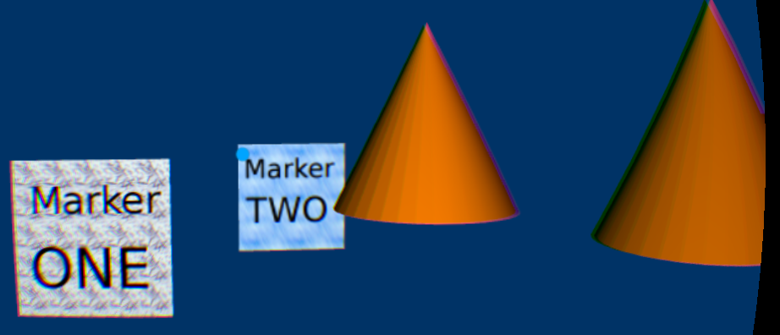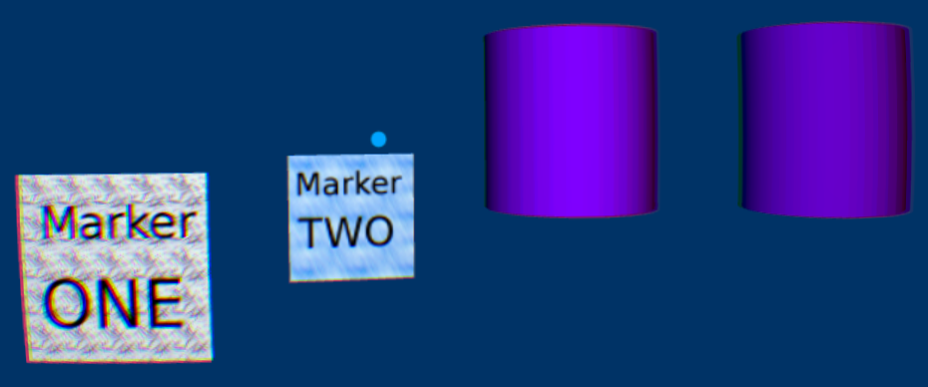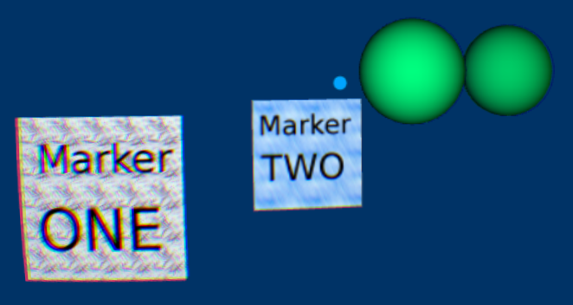

**Levelofdetail_mult_obj_Group.x3d**

Demo has 3 levels of detail. In level 1, from 0 to 4 units from the camera, “Level 1” texture map is shows with child objects with a dog and train (upper left image). The animation moves back just before “Marker ONE” panel 4 units from the camera, then slowly animates behind “Marker ONE” and reveals “Level 2” with its two child panels, both textured with “North-East-West-South” (upper right image).

Level-of-Detail 2 animates back to “Marker TWO) (lower left image) 9 units from the camera. The animation slowly passes “Marker TWO” at 9 units from the camera and changes to the third level-of-detail, which shows the single panel “Level of Detail 3”.

The animation continues moving back, reaches a final depth, then quickly animates back to its closest position, cycling through the 3 levels of detail and starts again.

There is also a panel with diagonal yellow and black stripes that animates forward and back in the same 30 second animation, but it is not part of the Level-of-Detail. It just adds another object to test the scene.

The three panels with “Level of Detail” 1, 2 and 3 use the <Group> node, a superclass of the <Transform> node that has no translation, rotation or scale information.

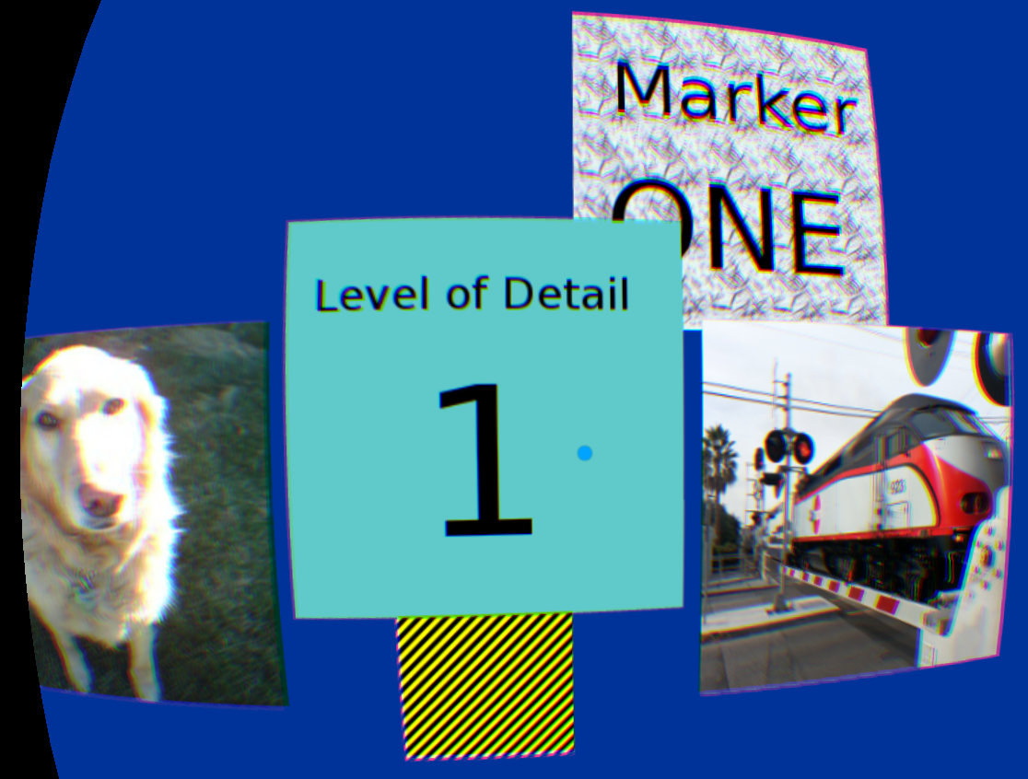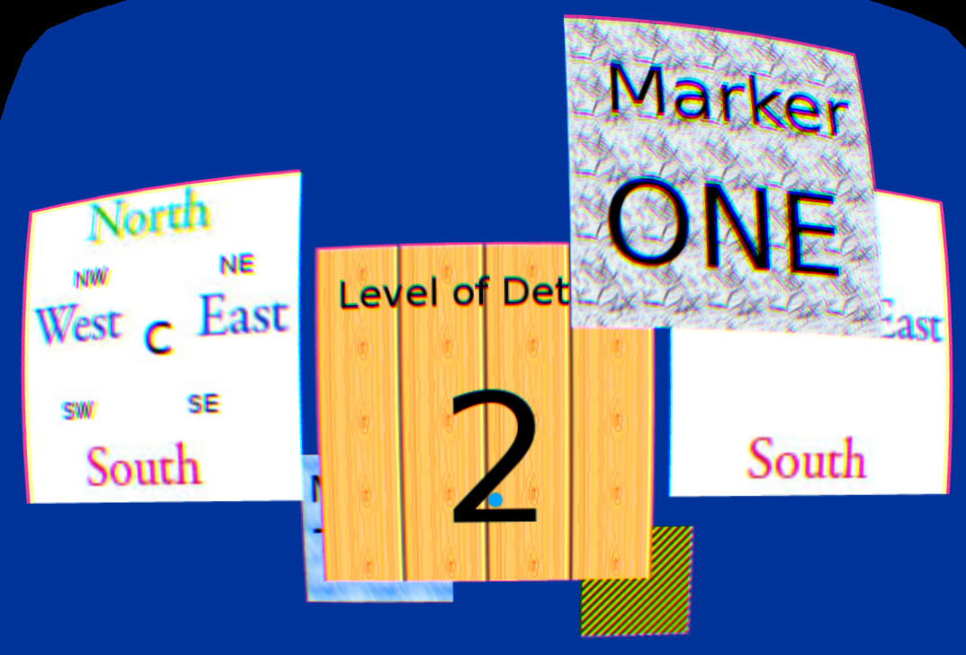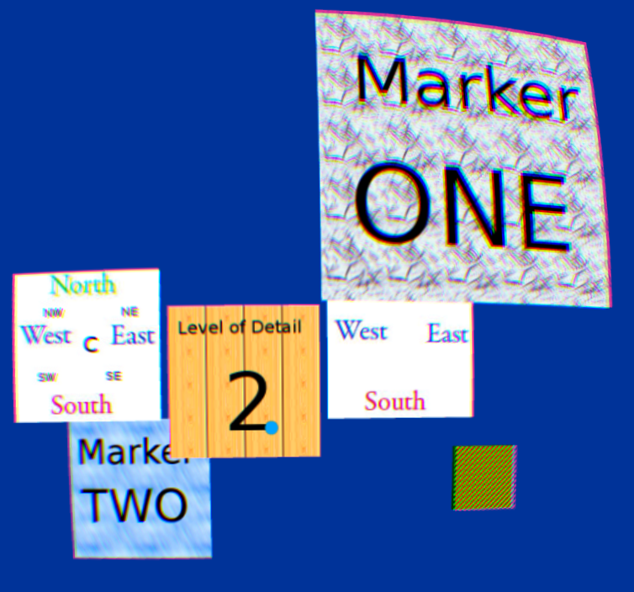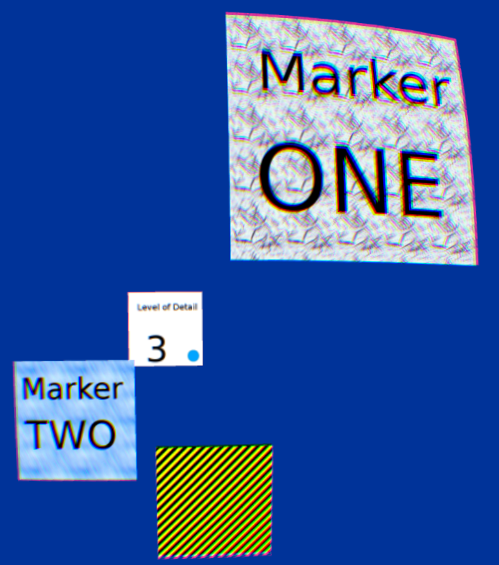

**Levelofdetail_mult_obj_Shape.x3d**

Same as the previous animation, but instead of <Group> nodes, it has just the <Shape> node.

**Levelofdetail_mult_obj_Transform.x3d**

Same as the previous two animations, but instead of the <Group> node containing a <Shape> node, it has a <Transform> node containing a <Shape> node.

**Levelofdetail_mult_children.x3d**

A variation of the previous three animations, however the “Level of Detail 1” panel has a child object of the dog, which has a child object of the train. “Level of Detail 2” panel has a child panel with “North-East-West-South”, which has a child object with a “C” in the center of its texture map.

